JMMS 6th Grade Supply List 2023-2024
- 1 three/four-inch regular 3-ring binder or zippered binder with dividers (Personal Organization)
- 1 pack of loose leaf/filler paper for your binder
- 1 three-ring pencil pouch to be kept in binder with the following supplies:
  - Pencils
  - Colored pencils
  - Washable Markers
  - Glue sticks
  - Highlighters
  - Scissors
  - 1-2 Dry erase markers
  - Inexpensive earbuds
- 2 folders with inside pockets (English and Math)
- 3 one-subject spiral notebook, 100+ pages (English, Math, and History)
- Envelope Document File Folder (Science)
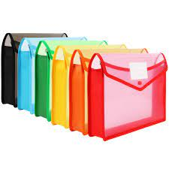

Supplies for Homeroom
- 1 pack of white or colored copy paper
- 1 pack of notebook paper
- 4 Boxes of tissues
- Hand Sanitizer
Supplies for Spanish Classes
- 1 100+ page composition notebook
- Pack of index cards
- English-Spanish dictionary (optional)

